**Name: Jai Anish Mehta SBU ID: 114834757 COURSE: CSE 534 FCN**

**ASSIGNMENT 2 - PART D**

**ADDITIVE INCREASE MULTIPLICATIVE DECREASE (AIMD) : FAIR (This plot will be used as a reference to show why other methods are not fair)**

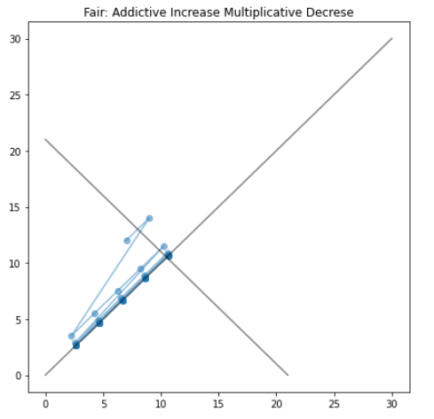

The plot below shows the trace for Additive Increase Multiplicative Decrease, and we can clearly see that, starting at point x=7 and y = 12 the points move towards the centre line that x=y and finally converges at the point where the flow x and flow y are sending equal data and are using the pipe optimally. It adds the to congestion window by 1 and on hitting congestion it decreases the window by halving it. It shows that after a few rounds it reaches a point where the throughput for both flows becomes equal. **Hence the Algorithm AIMD is fair.**

1. **MULTIPLICATIVE INCREASE ADDITIVE DECREASE (MIAD) : NOT FAIR**

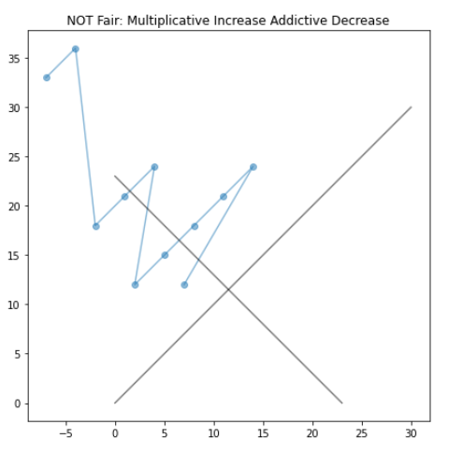

Let’s consider Multiplicative Increase and Additive Decrease. For this algorithm, we use the multiplication factor as 2 and the additive decreasing amount as 3. The congestion windows are increasing multiplied by 2 until congestion is hit, every time there is congestion the window size decreases by 3 for both flows. Starting with points x=7 and y = 12, we move in a direction (next points x=14,y=24), opposite to the line x=y thus we are moving to a state where throughput for flow x will not become equal to throughput for flow y. For one flow it will always keep increasing and for other, it will keep decreasing. Thus, it proves that this is not fair. **Hence this algorithm MIAD is not fair.**

1. 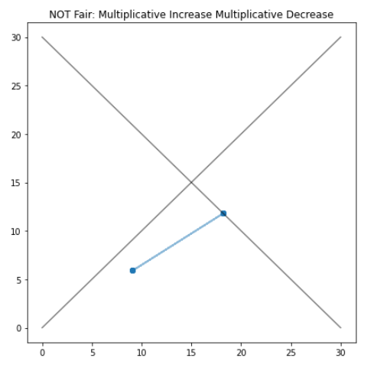**MULTIPLICATIVE INCREASE MULTIPLICATIVE DECREASE (MIMD) : NOT FAIR**

Let’s consider Multiplicative Increase and Multiplicative Decrease. For this algorithm, we use the multiplication increasing factor as 2 and the multiplication decreasing factor as w. The congestion windows are increased multiplied by 2 until congestion is hit, every time there is congestion the window size is halved for both flows. Starting with points x=9.1 and y = 5.9, we move to the next points x=18.2,y=11.8, where the congestion hits and it again returns back to the same point x=9.1 and y=5.9. This is demonstrated by the graph on the left and it appears to oscillate between 2 points. This won’t converge with line x=y and hence won’t be fair where the throughput is equal for both flows. **Hence this algorithm MIMD is not fair.**

1. **ADDITIVE INCREASE ADDITIVE DECREASE (AIAD) : NOT FAIR**

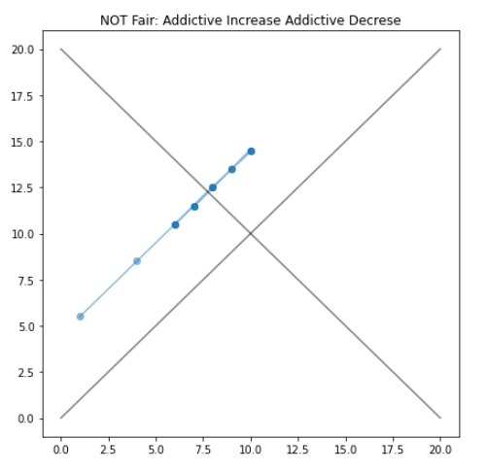Let’s consider an algorithm that does additive increase with the amount of 3 and does additive decrease with the amount of 2. Starting from the point x=1 and y= 5.5, when additive increase happens it will move to x = 4 and y =9.5. Let’s say congestion hits at this point, if this happens the x will become 2 and y will become 7.5. This shows us that increase and decrease will happen along the same line as we saw in the previous method as well. This will never allow us to reach a point where the throughput for both flows are equal. The graph on the left shows us that it does not converge to line x=y. **Hence this algorithm AIAD is not fair.**